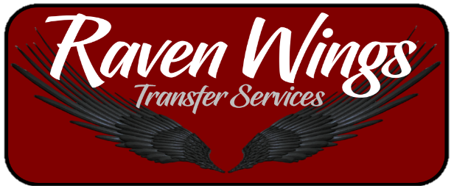

Stellenbosch Private transfer Pricelist
STELLENBOSCH - AIRPORT TRANSFERS
PAX | TRANSFER RATE
1 | R350
2 | R500
3 | R600

CAPE TOWN - STELLENBOSCH TRANSFERS
SAME DAY RETURNS ONLY
PAX | SINGLE | RETURN
1 | R500 | R650
2 | R600 | R750
3 | R700 | R850

ADD R30 extra for Surfboards and bicycles
ADD R30 for Campsbay
ADD R50 for Houtbay
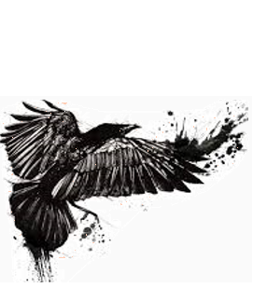
Booking Number: 076 632 1046
Email: bookings@ravenwings.co.za
OFFICE HOURS: 08:00 – 20:00
We also do group bookings but please contact office for Quote

